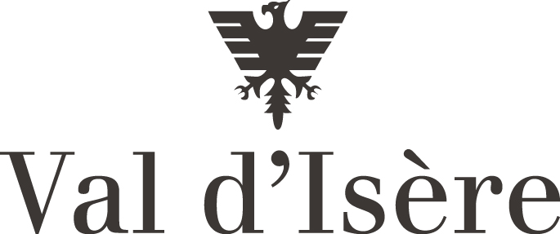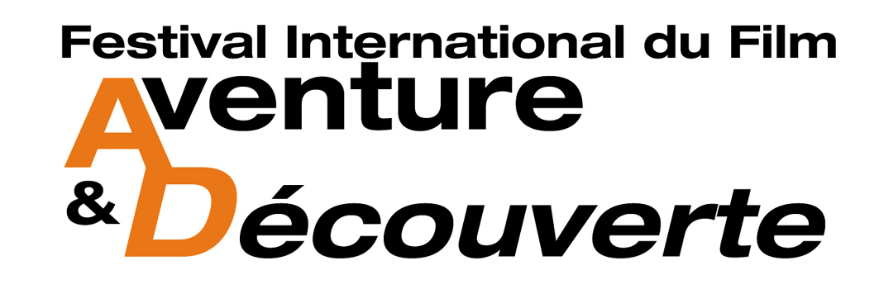

Val d’Isère from April 19th to 22th 2010

REGISTRATION FORM

Dear Sir, Dear Madam,

We have great pleasure in presenting the:
14th International Adventure Film Festival in Val d’Isère (Savoie - France).

The Festival, organised by the Val d’Isère Tourist Board, will take place at the Conference Centre from :

Monday 19th to Thursday 22nd April 2010

It is open to films presenting subjects mentioned in Article 2 of the enclosed rules and regulations.

Please return your registration form with a DVD tested beforehand by:

Monday December 7th 2009 at the latest

To Violaine SCHNEIDER RESIDENCE ELEGIE 73210 LANDRY

We would be grateful if you would pass on the rules and regulations to any other person who may be interested.

We hope to see your adventure soon, and we remain,
Yours faithfully,

FILM TITLE: ..............................................................................................……………...

DATE OF PROD : ......... LENGTH OF FILM : .......... COUNTRY OF ORIGIN : ....................

PRODUCER : ...................................................................................................................

ADDRESS : ...................................................................................................................

PHONE / FAX : ...................................................................................................................

EMAIL : ...................................................................................................................

DIRECTOR : ...................................................................................................................

ADDRESS : ...................................................................................................................

PHONE / FAX : ...................................................................................................................

EMAIL: ...................................................................................................................

Language of the original version: .................................................................................................

Does a subtitled French version exist?: .....................................................................................

Has the film been shown on TV? …… When?.... Which channel?.......

I, hereby, certify that I have read the Festival rules and regulations and fully accept them

Date : Signature :

Office du Tourisme
BP 22873155 Val d’Isère Cedex FRANCE
Fax : 33.4.79.41.12.06. // Email : festivals@valdisere.com

